Unit: Surface Processes/Chapter 10/Deposition
Name:__________________________________________ Block:__________________ Date:___________
(Vocab) Deposition:

- Most final deposition occurs in ________________________________________because running water is the most important natural erosional system, but before sediments reach bodies of water, they are deposited in different environments by :
- ________________ 2. ________________ 3. ________________ 4________________5. ________________
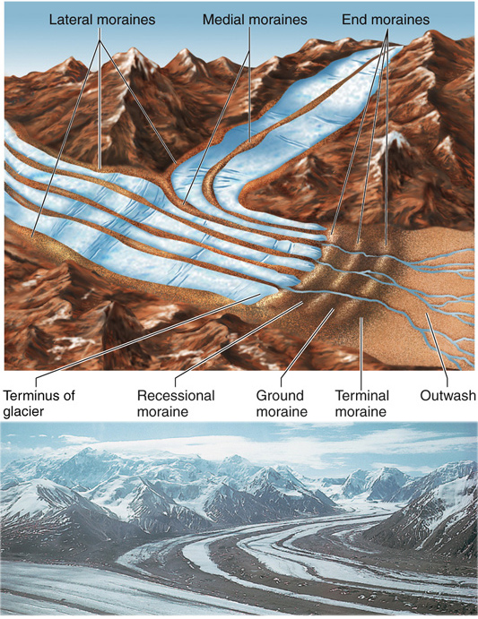
Deposition by GLACIERS:
- Moraines: along the bottom, edges and at the end of a glacier, the sediments it carries are just dropped in ____________________________ of sediment called ____________.
- A _________________ Moraine marks the furthest extent to where the glacier moved during glaciation
- A _____________ Moraine is formed due to a thin sheet of till accumulating at the bottom of a glacier
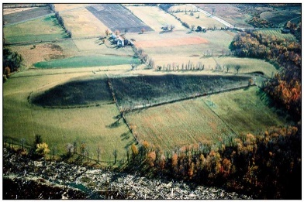
- If a glacier mounds up the ground moraine into an oval shape as it moves, it creates a _____________________
Drumlin
Recession:
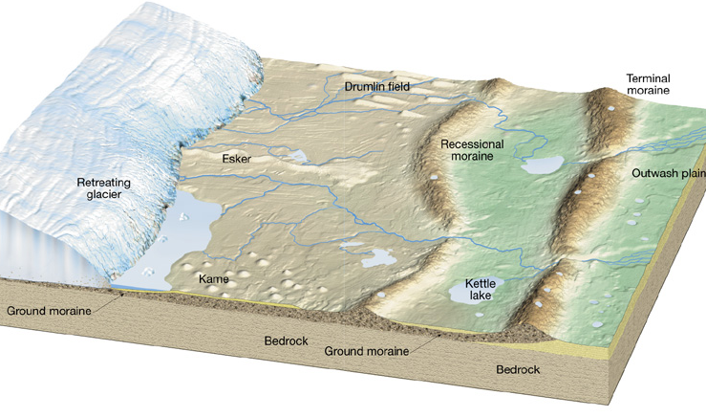
- Glaciers can leave behind ________________within the terminal or ground moraine as it melts backward leaving behind either a ______________________ or a ____________________
- Melting Glacial water will carry sediments from the glaciers to produce _____________ and ___________ sediments when the water slows down/stops. This is known as an ______________________________.
- ______________-are long winding ridge of sediments that are sorted and layered because they are deposited by running water from melt beneath the glacier
- _________________- are boulder sized rocks that were ______________ during advance and then _____________ by a glacier during retreat
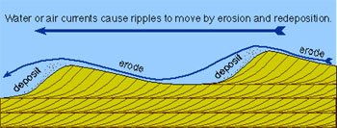
Deposition by WIND
- Wind generally deposits ___________ sediments over large spaces of land.
- ___________________ can occur when sand dunes migrate according to a change in ________________________
Deposition by WATER WAVES AND CURRENTS
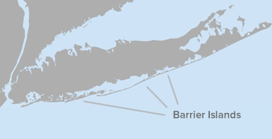
- ___________________- are created when an ocean/lake wave _______________ as it drags across the approaching shoreline and deposits a strip of sediment.
- ________________ will always occur on the side of a jetty/groin _____________ the longshore current
- ______________are created when longshore current transports sediment in the direction of longshore drift
- A _____________________________is created when the sediment on a sandbar piles up enough to grow vegetation and _____________________ the sediment.
Deposition by MASS MOVEMENT
- Deposition by a Mass Movement always results in ______________ sediments, usually quite ___________, being deposited at the ____________ of the slope/cliff. These sediments will be _____________(sharp edges)
Deposition by RUNNING WATER: How fast sediment is deposited in this system is determined by:
1. The velocity of the system
    - Faster velocity= _______________________________
    - Slower Velocity= _______________________________
    - Refer to pg. 6 of ESRT ! If a stream flows below a given velocity, it will deposit the sediments it can no longer carry.
2. The characteristics of the sediments themselves
    - Size- ______________ particles settle out _______________
    - Shape- ______________ particles settle out ___________, and flatter _______________
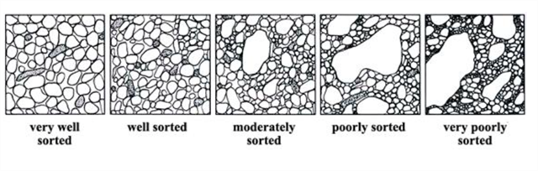
    - Density – ______________ density particles settle out ____________
The Sorting of Sediments in Deposition:
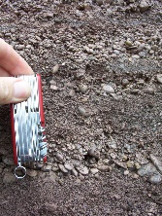
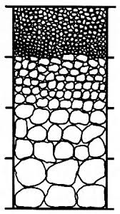
If a deposit or layer of sediment has particles that are similar in size, density, or shape, they are considered ____________.
When a mixture of sediments in water settle out rapidly, a ____________________ bed (layer) develops with sedimentary size ________________ from bottom to the top, creating ___________________________.

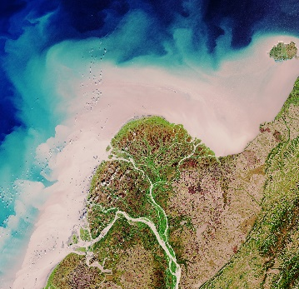
FORMATION OF A DELTA (Triangular track of sediment deposited at the mouth of a river)
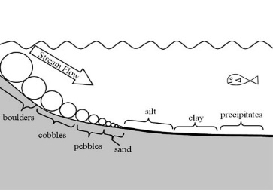
- When a river enters a larger body of water (lake or ocean), ___________________will occur as the stream velocity naturally ___________________ due to a decrease in ________________, and the collision of two flowing bodies of water. _____________sorting will occur, where larger, denser, and rounder sediments settle out ________________ while finer, flatter particles settle out last.
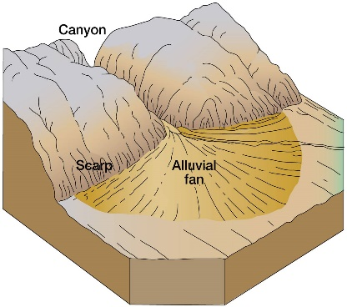
FORMATION OF AN ALLUVIAL FAN
Formed by running water in smaller rivers and streams at__________ altitudes. They carry sediment by erosion and deposit sediment over the ground as the stream fans out over a gentler slope, creating a _______________ shaped area of sediment.

